Samantha Kozak
LIBS 201-02

National Health Insurance: Healing, or Harming the Nation?

All over the news for the past two years American’s have been given an earful regarding Obamacare. The truth is, no one really knows if national health insurance is going to make the United States a better place, or if it is merely another plot made by the Government to obtain money from its citizens. This constant debate is scattering thoughts throughout the nation, making it time to lay out all of the facts, ending with a conclusion as to which Obamacare, or what is known officially as the “Affordable Care Act,” is making health insurance truly affordable for American citizens. Social equality among those enrolled is priority number one, however a majority of American’s are left paying a larger bill than previously expected.
According to the Obamacare facts page, one in every six Americans are paying a monthly premium of $100 or less under the ACA. (Affordable Care Act) One in six may seem like a good statistic, but it’s not. This means that there are five out of every six Americans that are paying more than $100 a month to be covered through Obamacare. Obviously, one can do the math and figure that out very easily, however it is interesting how the facts are being portrayed on the website. These five Americans are paying more to the point where it possibly affects them being able to afford insurance in general. The best part about not being able to afford the insurance, is when the government makes those who are not currently enrolled in some type of health insurance plan pay a fee.
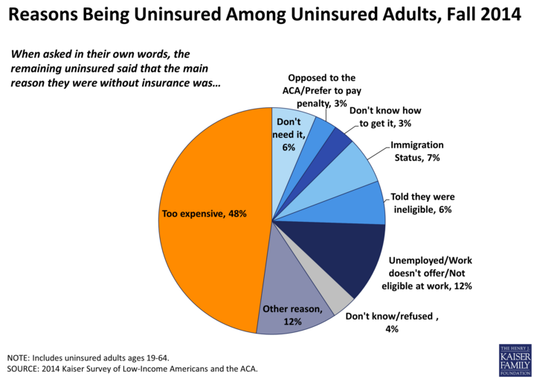
There is a blatant difference in someone who wants health insurance, but cannot afford the premiums they are required to pay, and someone who is lazy and does not want to sign up for health insurance. It is social injustice to have the government require those to pay a fee if they are not enrolled in any type of health insurance. There are also other problems that result with making everyone enroll in this insurance or being forced to pay a massive fine. In an article written by Dr. Gail Wilensky, he discusses the problems with the ACA. He states,
“[The ACA] ignores the structural problems in the organization and reimbursement of care — a limitation that is disappointing but not surprising: adding more people to the insurance rolls is politically and technically easier than finding a way to ensure that care is effective, high quality, and affordable for both the recipients and taxpayers”
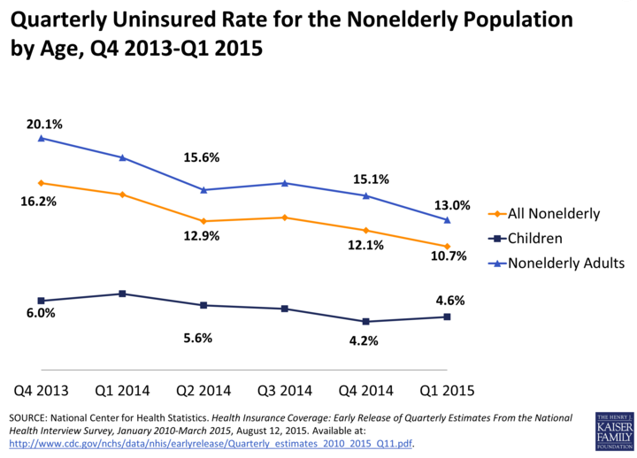
Expanding the amount of coverage to all American’s may sound like a great idea, however the quality and effectiveness of healthcare will diminish as time goes on, as well as make the rates of those with Obamacare increase.

Who are the people that cannot afford the premiums? They might be everyday people that surround us in our day to day lives. Over the course of writing this essay, there have been countless facebook posts dedicated solely upon the devastation they have found with trying to pay their health care premium through the ACA. The posts have included friends, family, and shared stories from strangers about how uneasy it has been trying to sign up with Obamacare. In a recent anonymous survey conducted by myself questions were asked to those on Facebook and other social media about their feelings with Obamacare or other insurance companies. Amongst some of the questions, the last one had received quite the impact. The question stated, “Were there any other troubles with becoming covered with Obamacare that you have encountered?” which a text box that allowed the survey taker to give a thorough answer. Some of these examples include paying over five hundred dollars in premiums every month, yet the second that they walk into a hospital, the deductible is over two thousand dollars. Another story expressed the feelings of a family with four children who could barely afford to pay his or her deductible of over five hundred dollars, yet the following month their premium shot up to over one thousand dollars. After refusing to pay those kind of monthly premiums, they then received a letter from the IRS claiming that he owes over two thousand dollars. The following is a direct quote from the last question : “I couldn't qualify for Obama care because my employer offered insurance which I couldn't afford. I had to go out and find insurance. Although I am insured I was told I may get hit with penalties because it isn't Obama approved” (Surveymonkey). So even though other health insurance may be used, if it not obamacare approved, some are still facing fines for not having proper insurance. How is this ethical in any way? The affordable care act is somehow ironic in which it’s actually not affordable for many families.
As young adults will be graduating and hoping to move out and on their own at some point, a large portion of the uninsured nation would be this age group. According to the Centers for Medicare and Medicaid Services or CMS, approximately 30% of those uninsured are young adults. This population of young adults makes up about one in five uninsured. A positive of the Affordable Care Act, is that this allows children to be on their parents policy until the age of 26. With this in mind, this means that less young adults will have to search for health insurance when they are no longer in college. Previously, the rule with Blue Cross Blue Shield was the age of 25, so the ACA expanded this by a full year. Some parents policies were for students only, and once their children were no longer in highschool or college, they were to be put on their own policy. This significantly impacts the way that the ACA has expanded coverage. In an article written in the Annals of Internal Medicine, young adults discussed the problems that they felt the healthcare.gov site had presented as well as suggestions that they would make. Their findings showed that the site was messy and “inadequately explained” (Wong 231). Not only did the youth find trouble picking a plan that covered all of their basic needs, most of them were expensive to the point that they could not afford it right out of school if needed. The college student is always stereotyped as being poor, however, there are still those who cannot afford coverage at all that are well about the young adult age.
Another example of those who cannot afford premiums would be homeless Americans from coast to coast. These citizens cannot afford a meal most days, yet under Obamacare, if they are not signed up to pay a premium, how do they get health insurance, and will they be forced to pay a fee? In an article from Dan Mangan, he shows a number of ways that homeless are signing up for Obamacare. The sad thing about all of this is that many were committing unethical acts in order to obtain the money to have health insurance through Obamacare. According to the article Mangan writes that some of the ways included: “handouts, barter or prostitution or drug sales” (Mangan). For health insurance to be provided for the homeless, they are making sure that they obtain a specific amount of money, otherwise they are forced to pay a fee from not being covered. How is it ethical to provide an additional fee to those who are not able to afford health insurance as it is? It is highly unethical to have the government collect these fees.
Through all of the negativity regarding national health insurance, comparing it to another country’s should shed some light on how different Obamacare is. According to the Association of Healthcare Journalists, there are many differences between national health coverage in Canada and the US. As explained by Trudy Lieberman, Canada’s health care system does not include tiers of coverage where those who pay a higher premium get better coverage. In Canada, all health coverage is universal which allows people of all different backgrounds, ethnicity, and gender to be able to get the care they need without being worried about whether or not they can afford their premium. With this health coverage not being privatized, this ensures that Canadian citizens of all incomes are getting the same health care. The wealthy are not the only who are receiving the benefits of health coverage, just as though they do in the US. In an essay by Health Services Research, a study was conducted between the US and Canadian Health system. The findings proved that Canada’s health care set up was allowing improved access to care throughout the country and “for individuals with high income and higher education, utilization rates were similar between the two countries and, in some instances, higher in the United States than those in Canada” (Pylypchuk 577). This finding shows that those with higher incomes were able to better utilize the health care system in the US rather than in Canada which was better designed for lower
income families. How ironic is it again that compared to Canada, the Affordable Care Act once again does not live up to its name? There seems to be nothing affordable about it. Although the ACA was recently introduced, this is still allowing a separation between the classes throughout the nation.
The affordable care act is making the average income and below income families suffer for not being able to afford the coverage. The government forcing those who are already struggling to pay a fine for something they cannot afford is forcing a powerless oppression throughout the nation. In an essay written by Iris Young, she explains the “Five Faces of Oppression” so that they can be sub categorized to help explain oppression more clearly in society. The third face of oppression can be found with powerlessness. She describes this as those “lacking authority, status, and sense of self that professionals tend to have” (Young 57). Those who are enrolling in Obamacare do not have the authority or status to feel as though they have power to change. The distinction between the higher class who can afford to pay these high premiums and deductibles are once again ranked above the middle and lower class. These classes are fighting for the chance to have health insurance for their families at an affordable level, yet some cannot afford it and once again are being forced to pay a fine. The higher class wins with getting health coverage for more of their family based upon income. Yet again, money controls position and ranking in the world. The wealthier the citizen, the better health care coverage. Healthcare should be universal so that no matter how much money is in the citizen’s pocket, regardless they will be treated with the best care.
Health care should be provided for all citizens at an affordable rate so that they can afford to be well and prosper. Spiking rates and providing penalties has no beneficial attribute for those who are in need of coverage. The only citizens who are benefitting from the affordable care act are those that are wealthy and can afford higher tiers of coverage and who do not have to pay fees on top of what they can already not afford. Making those in lower classes left feeling powerless when it comes to staying healthy and not being in debt is not the American way. Health should be provided for its citizens so that they know that they are being taken care of. These citizens are our friends, family, strangers, those in need of a home who cannot afford basic necessities, as well as young college graduates. These people should not be left feeling powerless, but be encouraged to stay healthy and prosper in the beautiful country that we live in. The Affordable Care Act is showing it’s true colors as not the most affordable health care coverage and proving to be socially unequal to US citizens.

Bibliography

Lieberman, Trudy. "Comparing U.S., Canadian Health Care Systems." Association of Health Care Journalists. AHCJ, 13 Jan. 2014. Web. 9 Dec. 2015.

Mangan, Dan. "Homeless Obamacare Enrollment Draws Scrutiny in NC." CNBC. CNBC, 17 July 2015. Web. 9 Dec. 2015.

National Center for Health Statistics. Health Insurance Coverage: Early Release of Quarterly Estimates From the Health Interview Survey, Jan. 2010 March 2015. Web. 9 Dec. 2015.

"Obamacare Coverage." Obamacare Coverage. Survey Monkey, 22 Nov. 2015. Web. 9 Dec. 2015.

"ObamaCare Facts: Facts on the Affordable Care Act." Obamacare Facts. Web. 9 Dec. 2015.

Pylypchuk, Yuriy, and Eric M. Sarpong. "Comparison Of Health Care Utilization: United States Versus Canada." Health Services Research 48.2pt1 (2013): 560-581.Academic Search Complete. Web. 9 Dec. 2015.

Wilensky, Gail R. "The Shortfalls Of “Obamacare”." New England Journal Of Medicine 367.16 (2012): 1479-1481. Academic Search Complete. Web. 9 Dec. 2015.

Wong, Charlene A., et al. "The Experience Of Young Adults On Healthcare.Gov: Suggestions For Improvement." Annals Of Internal Medicine 161.3 (2014): 231-232.Academic Search Complete. Web. 9 Dec. 2015.

"Young Adults and the Affordable Care Act: Protecting Young Adults and Eliminating Burdens on Families and Businesses." - Centers for Medicare & Medicaid Services. Centers for Medicare & Medicaid Services, 27 Jan. 2014. Web. 9 Dec. 2015.

Young, Iris M. "Five Faces of Oppression." Readings For Diversity And Social Justice. New York: Routledge, 2000. 39-65. Print. 9 Dec. 2015.

