Perla J Leyva-Sanchez
Prof. Hallerduff
December 9, 2015

“From Ferguson to Chicago: Black and Brown Lives are Disregarded”

Policy brutality has been linked to some of the most disturbing crimes in America. While researching some recent and past events, I found a few common trends. Citizens do not trust law enforcement; citizens do not respect law enforcement, and now citizens are speaking up more than ever about this social issue that is affecting our community. Why would this be the case? We are seeking change to what is becoming more and more evident, discrimination towards minorities in the hands of law enforcement.
It seems almost ironic that we would hear discrimination and law enforcement in a same sentence, especially when we seek the support of our police officers to protect and serve all members of our community. Instead, we’re encountering media headlines with titles such as “Unarmed Teenager Shot- X amount of times- by a Police Officer”. Being a native Chicagoan, falling under the Brown category, and living in a city that has alarming ascending homicide rates. I became curious to understand the breakdown of such numbers, as well as the reason why behind many decisions police authorities are making against our youth of color, ultimately adding a tally to the chart. Many interpretations to these cases can be presented and evaluated as self defense, as many trials can be revisited seeking a different outcome.. What is a clear, is the difference in percentage of black and browns lives affected by this evident social issue versus whites. Chicago alone having 2,724 murders to date (dnainfo.com- 2015) with a large percentage being unjustisfiable. The discrepancy in victim’s ethnic background, specifically with deaths due to excessive force in hands of law enforcement, has not had much of an improvement in the last decades. In reality, the violence of police toward minorities is not a new phenomenon; it has been an ongoing issue. This research will focus on the link between racism and policy brutality.
The police brutality background has quite a story to tell, specifically in Chicago. President Lyndon B. Johnson found the need to establish an organization that would address this issue dating back to 1968. The results are the creation of the National Advisory Commission on Civil Disorders (NACCD). Such organization conducted an examination in 1967, with the purpose of tackling the riots that erupted in the mid - 1960s, Chicago being one of the top four cities of concern. The report, officially labeled the Kerner Report, revealed several inequalities in America that privileged whites over other racial and ethnic groups. Unfortunately, we’re in 2015 and the issue appears to be as fresh as it did since the creation of NACCD or the worldwide case of Rodney King that followed in early -1990s.
A more recent research done by The National Police Misconduct Statistics and Reporting Project (NPMSRP) focused on examining how the public generally perceives our law enforcement and how race and racism shape such opinion. Those
two words required a further general interpretation to understand the overall perception of society. Marger provided such definition as: “racism is an ideology, or belief system, designed to justify and rationalize racial and ethnic inequality” (25) and discrimination, most basically, is behavior aimed at denying members of particular ethnic groups’ equal access to societal rewards” (57). Reading the definition of discrimination, it shares the connection to what is occurring with law enforcement. They are justifying racial inequality with their decision making of pulling the trigger on our African American and brown youth. I found that besides the above definitions, discrimination and racial stereotyping have a single sided point of view on the racist and discriminatory practices of law enforcement.
Embrick shares in his article: Two Nations, Revisited: The Lynching of Black and Brown Bodies, Police Brutality, and Racial Control in “Post-Racial” Amerikkka, a very relevant point of view. It quotes “media portrays minorities as violent perpetrators in need of social control, which allows for legislation in many white’ eyes for extreme police brutality and mass incarceration as a new form of lynching for the 21st century “ (Alexander, 2010; Smith, 1995). Unfortunately, such word fall in the hands of individual of power that are in charge of making drastic decisions, that may just be under very intense circumstances, but ultimately bias, with previous misconceptions of citizens.
Let’s address and start this argument with that specific word that refers back to power over blacks and browns, falling under the single story that Adichie shares in her many articles. Since the time that Africans were forcibly brought to America, they have been the victims of racist and discriminatory practices, by whites and those who create and enforce the law. In Punishing Race (2011), law professor Michael Tonry’s research findings point the fact that whites tend to excuse police brutality against blacks because of the racial disposition they hold against blacks (Chaney-Robertson 481). Whites believe that blacks are deserving of harsh treatment in the criminal justice system. In their research, they also suggested that black males are viewed as the “prototypical criminal” (Chaney-Robertson 482). Further research by Blair et al. (2014) revealed that that black males with more Afrocentric features, may receive longer sentences than black with less Afrocentric features (Chaney-Roberson 482). Such stereotype prevail as the main issue of the high crime rate in Chicago. The word racism appears to be the common denominator in the majority of the lives lost in the City of Chicago, lets discuss our most recent and very unfortunate case of Laquan McDonald.
As you may already follow the case of Laquan McDonald, 17 year old African American teenager shot 16 times by a Chicago Police officer in a Chicago’s side-side neighborhood. Although officer Van Dyke responded to the call under armed suspect. Based on the footage released after a year of the incident, showed Laquan walking away from the police officers, detouring at a steady pace, not at all as it was positioned in the initial report. An alarming idea is the thought of the many cases our city encounters, every day, that have had evidence hided or unfortunately just cannot support the story framed against them. The exposure to Laquan’s case surfaced the infamous issue that Chicago faces, and the reason why violence is so prevalent in our community. Do our police officers act on self defense or has it become the typical reaction based on stereotypical racial profiling?
Embrick’s statement on the views on race in the U.S “ There’s no denying that race continues to affect the lives of countless brown and black folks in America today, unless, of course, you are white” (838), mark the eminent connection between racial profiling or stereotyping as many can relate to the decision making a police officer can make. Below are statistic that address both the huge gap between African American and brown shooting versus whites and the alarming difference of civilians shot and killed by police in the United States in comparison to other large countries.
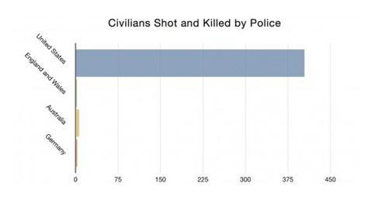
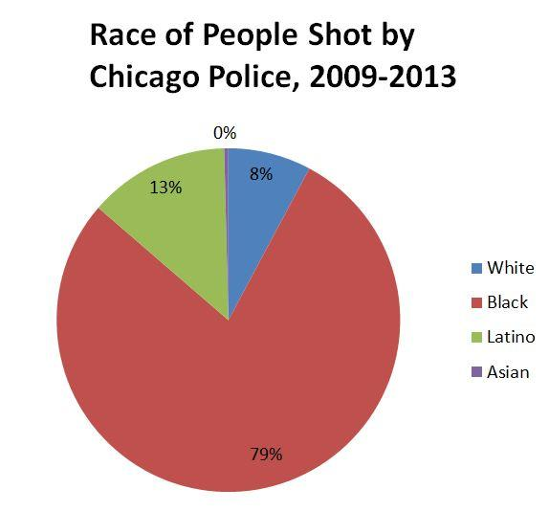
The protest that resulted in the conviction of officer Van Dyke played out to be the Chicago Race Riot of 1919 all over again. At that time, the main group known as the Hamburg Athletic Group included as a member and participant, a young Richard J. Daley, future mayor of Chicago. Is it safe to assume that the type of leadership a city goes through for decades builds belief?
After Daley’s retirement, the many issues this city encounters surfaced and now must be handled and addressed by addressing the root of the problem, if we ever want to see a change. Violence and crime is created by the lack of structure of the Chicago Police Department holds, the lack for training or maybe the ineffective training these officers are exposed to. After the release of the video, it created the first step needed to change this city: the resignation of superintendent McCarthy. “Now is the time for fresh eyes and new leadership to confront the challenges the department and our community and our city are facing,” Emanuel said.” These words were the best outcome to the peaceful two day protest this city faced during the peak of our holiday season.
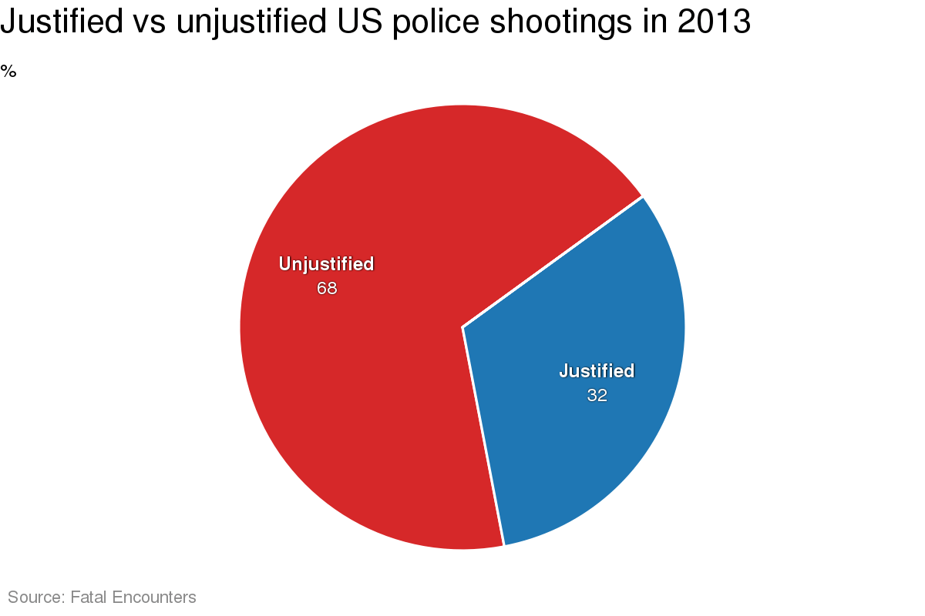

The reaction to this video is clear that the City is taking ownership of lost lives in hands of our police officers and now is taken a step further. The Justice Department will investigate the Chicago Police Department to see whether the force “ has engages in a pattern or practice of violation of the Constitution or federal law, Attorney General Loretta E. Lynch announced Monday, shares the Washington Post. The investigation will look at how officers use deadly force and examine any racial or ethnic disparities in how force is employed as well as how the department handles discipline and allegations of misconduct. Within the same investigation, Illinois Attorney General Lisa Madigan asked the Justice Department to investigate possible civil rights violations by the Chicago Police Department. Lisa Madigan described trust in the police as “broken, especially in communities of color,” and cited several incidents that were relevant of officers shooting people in the city of Chicago (Horwitz, Nakashima and Lowery).
Police brutality becomes such a topic of irony; we seek our law enforcement to be our protectors, not the reason why we’re burying our loved ones before their time with explanation that do not make sense, not only to the family, also to the general public. Large settlements are being offered as a method of consolidation for the death of our children, does that bring them back?

Works Cited

Alexander M (2010) The New Jim Crow: Mass incarceration in the Age of
Colorblindness, New York, NY: The New Press

Blair, I.V., Judd, C.M., & Chapleau, K. M. (2004). The influence of Afrocentric facial
features in criminal sentencing. Psychology Science, 15 (10), 674-679

Chaney,C. (2009). “So my family can survive”: Prisoner re-entry and the risk and
resilience of Black families. Journal of African American Studies, 15(1), 95-114. doi: 10.1007/s12111-009-9111-8

Embrick, David G. "Two Nations, Revisited: The Lynching of Black and Brown Bodies,
Police Brutality, and Racial Control in 'Post-Racial' Amerikkka." Critical Sociology 41.6 (2015): 835. Web.

Horwitz, Sari, Ellen Nakashima and Wesley Lowery. “Justice Department Will
Investigate Practices of Chicago Police.” Washington Post. The Washington Post, 6 Dec. 2015. Web. 6 Dec. 2015

Marger, M. (2012). Race and ethnic relations: American and global perspectives (9th
ed.). Belmont: Wadsworth

Robertson, R. 2011. A Pan-Africanist Analysis of Black Seminole Perceptions of Racism,
Discrimination, and Exclusion. Journam of Pan African Studies 4, 102-121.

Smith RC (1995) Racism on the Post-Civil Rights Era: Now you See It, Now You Don’t.
New York, NY: State University of New York Press.

