Dorina Badino-Berger
Professor Hallerduff
Writing Social Justice
8 December 2015
School Uniforms: Creating Uniformity or Stifling Creativity
Uniforms can be found everywhere you turn. A person is forced to wear a uniform when at work, prisoners are forced to wear uniforms, and some students are forced to wear uniforms as well. But, what do those uniforms say? At work, a uniform says an individual is able to adapt to their surroundings, able to follow simple rules and regulations, and, most importantly, able to portray the image the company wants to present to their customers. A prisoner wears a uniform in order for the guards to identify who is a prisoner and who is not. Simple. Right? But, forcing all the prisoners to wear the same thing does something else; it dehumanizes the prisoners. By forcing prisoners to wear the same thing, it takes away their ability to choose what goes on their body; it makes them look like everyone else. On the other hand, it also creates a sense of safety for the prison guards. They know that what the prisoners are wearing will not put their life or the life of their fellow guards in danger. Uniforms clearly have their advantage, but to what extent is the question many people are faced with and where the debate begins. Do uniforms stifle the creativity of young growing minds or does it create uniformity and eliminate the fear of fitting in, getting teased, and the amount of time and money it takes to pick clothes out for school in the morning?
While the debate over school uniforms seem to be on the rise, the reasoning behind the arguments tends to remain the same. The biggest issue at hand is how uniforms effect the students. Research shows that uniforms do, indeed, benefit children in more than one way (Boutelle). By requiring a uniform, studies have shown a decrease in violence in the public schools that have chosen to adopt a school uniform policy (School Uniforms - ProCon.org). Other benefits of wearing a school uniform include: lowering of crime, increase of safety, ability to focus on what they are learning rather than what they are wearing, saving money on clothes, decrease in bullying, and helps prevent students from wearing gang affiliated clothing to school (Should Students Have to Wear School Uniforms?).
While these are all great benefits of school uniforms, the argument still exists of whether or not students are capable of expressing who they are without the ability to wear what they please. Students claim that their clothes assist in making their mind grow, aids them in becoming more independent, and helps present themselves as unique (School Uniforms Stifle Freedom of Expression). By forcing students to wear uniforms, students feel they are losing all those qualities that not wearing a uniform grants them.
Although, what most students do not consider is their ability to express their freedom and individuality through their uniforms. Most uniforms give students the opportunity to choose from a variety of colors, if the uniform requires polos. Another option granted to students is their ability to choose what type of pants they want to wear, whether it be pants or shorts or if you are a female pants, shorts, skirts, jumper, or a skort. Another fact often overlooked is the student’s freedom to wear whichever type shoes he/she desires along with any color or style of socks he/she chooses (Kizis).
As demonstrated, a student’s creativity is not limited when forced to wear to uniforms, much like my creativity was not stifled when told to write this research paper. That is why I chose to write the first have of my paper in blog form. I was given the guidelines but was also granted the choice on how to relay this information. To express this information, I chose to write a blog post in order to relay the message of my paper in a creative way, yet still followed the guidelines given to me, much like school uniforms. It is believed that writing a research paper stifles a student’s creativity because all research papers are the same. But, students are granted the freedom to choose their own topic and this case write their research paper in the way they desire. Uniforms are the same way: students will be given a choice of shirts and pants to wear and they have the choice to choose which one they will wear for the day, which is still permitting creativity.
Often times, the most overlooked argument is the school dress code already present in school systems (Wilde). Schools already restrict students’ “creativity” by enforcing this dress code. They are restricted to what length their shorts can be, how much skin can be showing, and told what shirts are considered appropriate and inappropriate. The differences between school uniforms and dress codes are very small. If parents and schools both approve of dress codes, the jump to school uniforms is not that big.
I chose to write about school uniforms in specific because it is a topic I feel passionate about and after reading the research found that my ideas were supported through statistics. When I attended private school, I loved wearing my uniform; it was one less thing I had to worry and after reading the research found that my ideas were supported through statistics. When I attended private school, I loved wearing my uniform; it was one less thing I had to worry about in the morning. I did not have to worry about if my pants were in style or if my shirt was unflattering because we all were wearing unflattering clothing. When I switched to public school, I found too much time was being wasted trying to decide what to wear to school that day; deciding what to wear became a burden to me.
Overall, school uniforms benefit children far more than allowing them to wear whatever they desire to school. Parents are able to save money because they do not have to worry about dressing their child for school daily, bullying in the classroom will dramatically decrease because of the uniformity, gang violence will decrease, and academic progress of the students will increase. While the argument remains strong of the students freedom being taken away from them, students can and will still express their individuality through other methods and clothing choices.

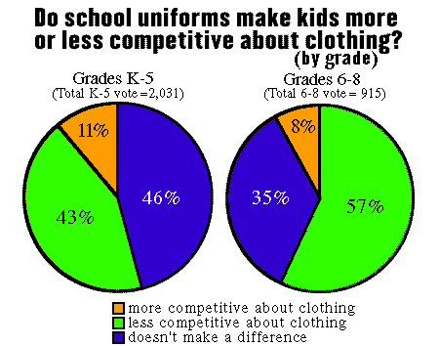
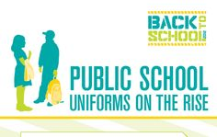
Works Cited

Boutelle, Marsha. "UNIFORMS: Are They A Good Fit?." Education Digest 73.6 (2008): 34-37.
Academic Search Complete. Web. 8 Dec. 2015.
Chen, Grace. "Public School Uniforms: The Pros and Cons for Your Child |
PublicSchoolReview.com." PublicSchoolReview.com. Public School Review. Web. 4 Dec. 2015.
Kizis, Sarah. "School UNIFORMS And Dress CODES: The Pros And Cons." Writing 23.1
(2000): 18. Academic Search Complete. Web. 8 Dec. 2015
Rockney, Randy. "Should School Uniforms Be Mandated In Elementary Schools?." Brown
University Child & Adolescent Behavior Letter 21.5 (2005): 8. Academic Search Complete. Web. 8 Dec. 2015.
"School Uniforms - ProCon.org." ProConorg Headlines. 14 Sept. 2014. Web. 4 Dec. 2015.
“Should School Uniforms Stifle Freedom of Expression.” Web. 4 Dec. 2015.
"Should Students Have to Wear School Uniforms? - School Uniforms - ProCon.org."
ProConorg Headlines. Web. 4 Dec. 2015.
Wilde, Marian. "Do Uniforms Make Schools Better? | GreatKids." GreatKids. Web. 4 Dec.
2015.

