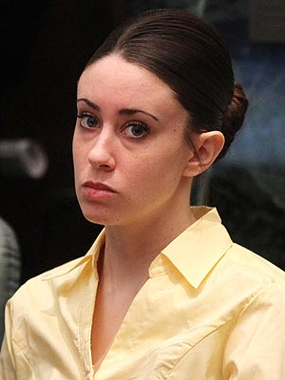
Natalie Verr
Professor Hallerduff
LIBS 201
Final Paper
December 9, 2015
Laws are social rules that apply for everyone to follow. It is these set of regulations which protect any society from going chaotic. When someone violates a law, they need to be held accountable for their wrongful actions with a consequence. The people that enforce the law are humans, so people with more power tend to escape these consequences when they fail to abide by the law. According to, Poor People Lose: ‘“the law is not a fixed and determined system, but rather an unruly miscellany of various, multifaceted, contradictory practices, altering from to time and from context to context as different features” (Butler, 57). Which I agree with! How are these people powerful? Well, some are powerful because they have money, a lot of it, or if they are famous. Usually money and fame determines how much power one might have in a society. Why is it okay for those type of people to walk under the radar when they break the law, but not your average Joe? Powerful people do not just get away with little crimes such as a speeding ticket but ones that they should be locked up for life! There are plenty of cases where wealthy or famous people get away with crimes, but the two examples I will discuss about Casey Anthony, and Colton Couch. What are some reasons why they did not have to do time for their actions? Is there a way as a society to hold them accountable for their actions?
Casey Anthony was a women in her prime! In her later teen years she got pregnant with a baby girl that she names Caylee. What is interesting to note is that she convinced her mom Cathy (until she gave birth) that she was actually not pregnant. So, her mom too was lying to their family members and friends telling them that Casey had a tumor or just a lot of water weight (“Casey Anthony Biography” 1). Casey’s mom has been baking her lies up since high school. Casey was not going to graduate from high school and her mom never told her family members. Her grandma was at the school, called Cathy asking why her granddaughter is not walking down the stage and that is when grandma found out her granddaughter is not graduating (2). Most mothers would warn their family members especially grandma if something like that is happening even if it does embarrass the family. They would not be making up lies for their child not matter how much they love them. Casey did not want the responsibilities of having a child, she wanted to stay out and party because she is young. Three years go by after she has the baby, Casey leaves her parents with Caylee because of an argument. Then, “thirty-one days later Caylee's grandmother, Cindy Anthony, reported to police that Caylee had been missing and that the car which Casey had taken from her "smells like there's been a dead body in [it]” (Battaglia 4). If I were the police Casey would be my first suspect and this would be the first evidence towards her. Which it was for the police, but she told the police that it was her nanny that kidnapped her and killed her daughter. Most mothers would have reported it right away if their child was missing (for even a day) and crying. Casey on the other hand was, “partying, getting a tattoo, and ultimately showing that "Caylee's death allowed Casey to live a good life, at least for those 31 days" until her arrest” (4). After that she got arrested three times for, “charges of child neglect, obstructing a criminal investigation, and filing false statement, check fraud and theft and more theft charges” (4). To me this sounds like a guilty women! She does not sound like a motherly person if she keeps getting arrested for stealing. Since they had no body to examine they could convict her of being guilt, but “On December 11, 2008, the remains of a young child were found near the Anthony home and it was later confirmed, by renowned medical examiner Dr. Jan Garavaglia, to be the remains of Caylee” (4). BAM! Another key evidence that is pointing to her, but the trial is not over. Later into the trial Casey’s family said that Caylee drowned in the pool and was spiraling into a big accident (4). Which I say lie! In those situations you call for help, try giving CPR and not wait thirty-one days to all the authorities that your granddaughter was missing. The Anthony’s really like to lie. “During the second week of the trial, the jury heard witness accounts from Casey's mother, brother, and father; they heard recordings such as police interviews, jailhouse visits, and the 911 call, and finally testimony that Casey had been avoiding her parents during the thirty-one days Caylee was missing” (5). Her parents need to stop lying for her and just let her deal with the consequences of her actions. That is the only way she going to learn that it is not okay to lie. After many months in trial the jury came to the conclusion that she is NOT guilty! Which surprised every person watching her trial. It would be nice to know why she was not considered guilty by the jury when there was so much lies going on and situations pointing to her. Casey Anthony was a regular women, but after her trials the media followed her everywhere! So, since everyone was watching her and getting interested in what happened to her daughter she became famous overnight. Maybe that is why she got away with the murder of her child because of her status in society. It is not right that she gets to walk away without punishment for her actions, but she will have to deal with the emotional punishment later on in her life or who knows she might be struggling with it already!
Her facial express throughout all her trials. The look of: ‘I don’t care.’ ‘Why am I here again?’ ‘No remorse.’
Caylee-The little girl that tugged most people’s heart strings! {RIP}
Biography of her (Anthony’s) past and the trials. Copy & Paste to watch it. http://www.biography.com/people/casey-anthony-20660183
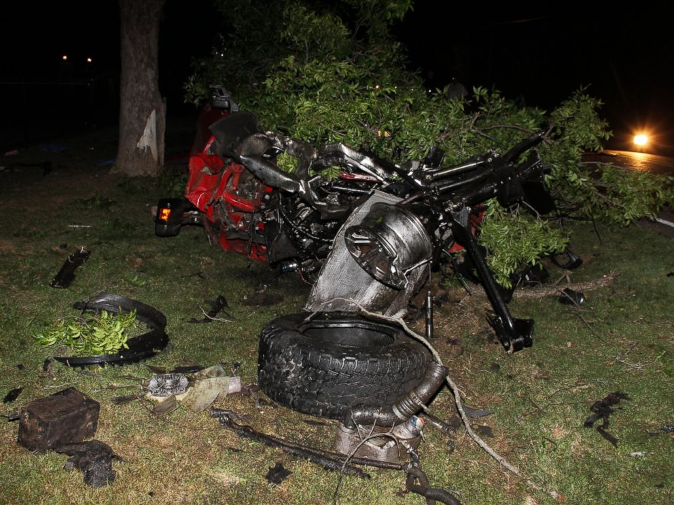
Ethan Couch a single child with millionaire parents or should I say dad. It all started in June of 2013 in a town in Texas, but let me start from his earlier childhood days. Ethan grew up in a home where mom and dad never said no to him and let him do or have whatever he wanted. This child has never heard of discipline. He started driving at the age of 13 and he started driving to school too. One of the teachers noticed that we was driving below the age limit and brought it to the parent’s attention. Mr. Couch was not happy to hear the compliant, so he said he will buy the school and make his own rules, but instead he decided to take his son out of school and get him home schooled (Dooley and Effron). I wonder how much schooling actually happened if his parents did not have enough time to discipline their child. By age 16 he had his own Ford truck! Ethan’s family were in the process of moving into a new home. His parents moved into their new mansion and left Ethan at the old house for a few months. So, Ethan took this as an opportunity to have parties and have a bunch of drugs and different kinds of liquors and beers. He had a few guys over and his love interest and after they engage in a ton of drinking the girl decides she needed something at the convenient store and Ethan insisted on driving. His friends were pleading him not to drive, but Ethan won that argument. That night he was playing chicken with other cars and was going 70 miles per hour (Dooley and Effron). Also that night his neighbors were having parties, there was a car helping another change a flat tire, and a graduation party. Now we get to a late night in June when Ethan crashes his car, kills four innocent individuals, injuries other individuals and he manages to exit the scene with a few scratches. When the paramedics found him in a lawn they insisted on taking him to the hospital to make sure he is good. When they took his blood, he had blood alcohol level three times an adult and it was two hours after the accident (Dooley and Effron). I could only imagine what it could have been before the accident! Now, Couch should have been arrested and charged for 20 years, but instead he got 10 years of probation and time in a rehab facility (Dooley and Effron) because he suffers from affluenza. Affluenza is, “a metaphorical illness connoting hyper investment in material wealth, which is rapidly spreading among upper middle class and white collar families” (Luthar et al, 4). He never once apologized to any of the families of the loved ones he took away. In my opinion I believe the judge and psychologist are pretty much telling this boy that the law does not apply to you-which you can do these horrible things and get away with it. It effects almost everyone that is not wealthy because if roles were switched I would get the 20 years in prison and so would anyone else in the lower and medium class would. The laws are set to keep other people safe, if you do not abide by it than consequences happen to those who do not. This situation should’ve been a learning experience for Ethan that you cannot just do something and get away with it or you have mommy and daddy pay you out of your situation.
One out three different aspects of the accident. You can see behind the fallen tree Ethan's red Ford truck.
Couch walking into the court room.
Watch what happened detail by detail. From ABC 20/20
Most people wonder how in the world can these people slide under the law like that! There are many factors and reasoning’s on why this happens. Majority of people think famous people, for example: OJ Simpson (whom I did not mention, but Casey’s was compared to him), get away with the law but that is not the case. It is unfortunate that this is the case, but humans do not play fair in life. According to the article “Slipping Away Justice,” The ranks of private lawyers doing criminal work include the few tope men in the city, baffled family lawyers whose clients fallen into the hands of the police, hacks who find their clients in halls of the criminal courts building, corporation lawyers whose clients ask them to perform the work as a service and young men on the way up who mix criminal and civil practice” (Shinall, 30). These are the situations when people actually pay off the court or police so they can get away with whatever. Another reason for some people to get away with the law is, “Variables such as location and practice area, as well as personal characteristics like race and gender could feasibly create systematic differences in attorney trail outcomes” (13). It is no surprise, if you live in a wealthier neighborhood that your outcome would be better. Not everyone is lucky enough to be in a place where they can have a good lawyer to defend them even if they were wrong! Just like the Anthony case, “Much of the media believes that an attorney can decide a case. Get a good enough attorney, the story goes, and can get off anything” (12). In Western Society it seems like the more money you have and the more publicity one has the more power they hold and do whatever they want.
Both of the examples needed a slap in the face from the law, but as we all know that did not happen! How will they learn that they cannot just get away with whatever they feel like and be okay with it? If laws are meant to bent, stop putting innocent individuals into jail and putting the right ones in. My hope is that you too feel a sense of anger and disbelief that these two examples got away with what they did.

Work Cited
Battaglia, Nicholas A. "The Casey Anthony Trial and Wrongful Exonerations: How "Trial by Media" Cases Diminish Public Confidence in the Criminal Justice System." Albany Law Review 75.3 (2012): 1579. Web.
Butler, Paul D. “Poor People Lose: Gideon and the Critique of Rights” Yale Law Journal 122.8 (2013): 2176. Web.
"Casey Anthony Biography." Bio.com. A&E Networks Television. Web.
Dooley, Sean, and Efron, Lauren. "'Affluenza' DUI Case: Never-Before-Seen Deposition Tapes Reveal New Details of Fatal Crash, Teen’s Upbringing." ABC News. ABC NewsNetwork, 16 Oct. 2015. Web. 18 Oct. 2015. <http://abcnews.go.com/US/affluenza-dui-case-deposition-tapes-reveal-details-fatal/story?id=34505481>.
Luthar, Suniya S., Karen A. Shoum, and Pamela J. Brown. "Extracurricular Involvement among Affluent Youth: A Scapegoat for "Ubiquitous Achievement Pressures?” Developmental Psychology 42.3 (2006): 583-97. Web.
Shinall, Jennifer Bennett. "Slipping Away from Justice: The Effect of Attorney Skill on Trial Outcomes." Vanderbilt Law Review 63.1 (2010): 267. Web.

