Malia Hurst
Professor Hallerduf
Writing Social Justice 201
December 6, 2015

The Military’s problem with Mental Illness

Mental illness in the Military is becoming a serious issue and is becoming more prevalent every year. When people think of the Military and its personnel, they imagine bravery, courage, honor, commitment, and patriotism for their country. But what people don’t know and/or see under all of that courage and bravery is an invisible battle with the military personnel’s mental health. According to a Harvard study, “almost 25% of nearly 5,500 active duty military personnel have mental disorders” (Willingham). And what’s horrifying about these numbers is that most of the Military personnel don’t even know that they have a mental disorder. Some Military personnel may know that they have a problem but may feel too ashamed and embarrassed to go and receive help for their disorders. But the Military personnel who do go and try to receive help can sometimes be misdiagnosed and/or mistreated. Being misdiagnosed could mean that the Military personnel is being told that they have two or more mental disorders when they really have one disorder or being told that they have one disorder when they really have two or more (in this case that would mean being under diagnosed). Being mistreated could mean that the person is being given too little or too much pharmaceuticals, which could cause harm to the individual taking the medicine.

Some of the mental disorders that Military personnel may have are: Depression, Bipolar Disorder, Post Traumatic Stress Disorder (PTSD), and Schizophrenia just to name a few. Depression is a kind of mood disorder that harbors feelings of sadness and sudden loss of things

that use to interest you. “You may have trouble doing normal day-to-day activities, and sometimes you may feel as if life isn't worth living” (mayoclinic.org). Bipolar Disorder is a disorder that harbors sudden mood changes within the individual. These mood swings could go from being high and feeling happy to being low and feeling sad sometimes lashing out on other individuals. “Post-traumatic stress disorder (PTSD) is a mental health condition that's triggered by a terrifying event — either experiencing it or witnessing it. Symptoms may include flashbacks, nightmares and severe anxiety, as well as uncontrollable thoughts about the event” (mayoclinic.org). Finally, Schizophrenia, which is a brain disorder, can harbor some “combination of hallucinations, delusions, and extremely disordered thinking and behavior” (mayoclinic.org). There are other mental disorders that military personnel have, but these four are more prevalent when Military personnel are seeking help.

With these disorders, many of which could have come from before being in the military, seem to be affecting many military personnel’s lives. They could be very mild which all you would need is a few days of counseling for or they could be severe in which you would need many months of counseling with one or two prescribed medications. But even with treatment, some military personnel are not being treated but may not be receiving the right treatment and/or
may be receiving the wrong diagnosis. This is an important issue because the military personnel could harm his/her self and/or others if they are not receiving the right diagnoses and treatment. And when I say treatment I mean as far as counseling, therapy, and medication. But sometimes when a military personnel is given certain types of medication they are being mistreated as well

because they are either given the wrong medication or are given too much of the medication or both.

When I first joined the Army, I felt normal and I was really happy. Of course if things didn’t go my way or as planned I would get a little frustrated or get upset, but I would get over it. It wasn’t until after being in the Army for about a year at my Army post in Fort Carson, Colorado that I noticed a big change in my behavior. I slept more and didn’t want to get out of bed, now any person would think that is normal especially with the hours that I was working everyday. But for some reason I just wanted to sleep all day and night with my curtains closed, no T.V., and no music nothing. I noticed that my appetite had changed drastically and I went from being at a healthy weight of 125 pounds to 106 pounds. I lost interest in a lot of things that I loved doing like dancing, cooking, and talking on the phone with my friends.

Soon my husband began to see the change in everything I did as well and wondered what was wrong. But I didn’t know and I would often blame it on just being home sick. Then one day at work my unit had a meeting and discussed some of the programs that were available to Soldiers on post. Many of the programs were mental health related since my post was experiencing a lot of suicides and murders of Soldiers. Then I realized that maybe that was the problem I needed to seek mental health treatment or at least try and talk to someone who could possibly help me, so I did. The first place I went to on post was a Behavioral Health Clinic and I thought that the person that I would be talking to would be a Psychiatrist or at least a Psychologist. But instead I spoke with a Social Worker, which to me was a little odd because I thought Social Workers dealt with family cases dealing with children and elderly people. When I told the Social Worker what I was going through I felt as if she didn’t really care and I was only in her office for about 30 minutes and then it was over. The next time I went was a week later and it was the same routine except this time she gave me a diagnosis of not only having Depression but of also Bipolar Disorder, and Post Traumatic Stress Disorder (PTSD). That seemed a little odd because yes I was feeling sad but to tell me that I had all of these conditions really shocked me. I felt as if I were crazy as well. Then I was taken to a Psychiatrist who prescribed me 2-3 medications saying that I would get better within a month and that was it. I then went home told my husband who immediately told me to throw away the prescriptions and to go and get a second opinion.

I went to another Behavioral health Clinic and this time I did speak with a Psychiatrist who told me that I had a mild form of Depression but did not prescribe me any medication. She also advised me that she would schedule me into some group therapies and advised me to go for walks, eat healthier, and try doing some new activities. After about 3-4 months of this, I got better and I overcame my Depression. I even began to gain some of my weight back and started doing the things that I loved again. I was really happy and glad that I got a second opinion.

Now imagine if I wouldn’t have done this and just had taken the Social Workers advise and had taken the prescribed medication, I don’t believe that my ending would have been so happy. I believe that I would have been even more depressed and my condition would have
worsened. I also believe that I would have hurt myself or even worse committed suicide like so many of the Soldiers on post. My experience alone is proof of the when someone is over

diagnosed and not given the right type of mental health treatment. Unfortunately, many of the Soldiers are not as lucky and go and get a second opinion like I did. They believe that because the person who is treating them is a professional and know what they are talking about when actuality they probably don’t know what they are talking about and are not helping individuals and their lives but actually harming them.

As I said before misdiagnosing individuals can be very dangerous and could cause harm. According to the article by Allen Frances a Professor at Duke University he says that:
“Careless diagnosis then leads to careless treatment. Rates of prescribing psychiatric drugs have skyrocketed, as has polypharmacy -- that is, the use of multiple, often interacting drugs, often in recklessly high doses. Several hundred troops die each year from accidental or deliberate overdoses of prescription drugs” (Frances).

So, who is harmed due to not treating these disorders the right way? The people who will be harmed is everyone including the military personnel because depending on what type of mental disorder that they have, they might cause great bodily harm to others as well as themselves if they snap or “blackout”. With that being said I believe that the military should have more training and a better understanding of how to treat individuals with mental health issues,

because if they don’t receive the proper training it could lead to a lot more deaths and potential lawsuits if it becomes a crime.

I believe that this issue is an example of social injustice because these men and women in the military sacrifice their lives to keep America and its occupants safe and they are not receiving the right mental health care. It seems as though the people who are suppose to treat and help these individuals are not really educated on mental illnesses let alone on how to treat them. In fact most of the people who do the diagnosis are Social Workers and not Psychiatrist. They seem to feel that all the individual would need is a few counseling sessions and a prescription for the assumed disorder. And that combination is not only misleading but also harmful.

When trying to connect this issue with one of the theorist that was discussed in class, I believe that Charles Taylor would be a close enough connection. Taylor discussed much about being recognized and misrecognized and I believe that the military personnel who are misdiagnosed and mistreated are not being recognized especially when it comes to their mental health. It seems like they treat these individuals as lab rats to see how and if the treatments would work and most of the time it doesn’t. I also believe that when they are over diagnosing the Soldiers various medications, that not only is it a way to test the medication to see how it would work but also a way in which the pharmaceutical companies can receive more money. That would also be considered social injustice because what is being said is that the Soldiers in the Military are not human beings who sacrificed their life but lab rats and test subjects for medication.

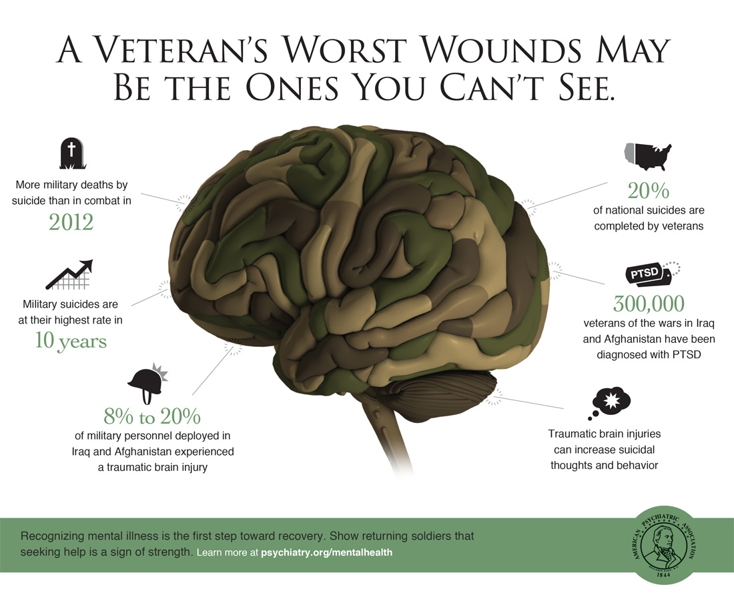

Ultimately, the mental health of Military Soldiers is a very important and serious issue. They risked their lives to keep America safe, shouldn’t America do all that they can to keep the Military personnel’s mental health safe as well. Individuals in the Military shouldn’t have to deal with not receiving quality mental health. It should be given to them honestly and with care and compassion because these individuals will one day enter into the civilian world. The people who work to help these individuals should focus more on giving these individuals the right care instead of just giving them extra medication and the wrong diagnosis. At some point in the future the Military will get it right, lets only hope that it is sooner.

Bibliography
Dingfelder, Sadie F. The Military's War on Stigma. 2009. 22 November 2015 <www.apa.org/monitor/2009/06/stigma-war.aspx>.

Eve Pietrzak, Stephen Pullman, Cristina Cotea, Peter Nasveld. Effects of deployment on health behaviours in military forces: A review of longitudinal studies. 21 November 2015 <jmvh.org/article/effects-of-deployment-on-health-behaviours-in-military-forces-a-review-of-longitudinal-studies/>.

Frances, Allen. Reported High Rates of Military Mental Illness Are Wrong and Dangerous. 2014. 20 October 2014 <http://www.huffingtonpost.com/allen-frances/reported-high-rates-of-mi_b_4905631.html >.

Hans Pols, Stephanie Oak. War and Military Mental Health. December 2007. 21 November 2015 <www.ncbi.nlm.nih.gov/pmc/articles/PMC2089086>.

Joie Acosta, Amariah Becker, Jennifer L. Cerully. Mental Health Stigma in the Military. 30 September 2014. 22 November 2015 <www.rand.org/pubs/research-reports/RR426.html>.

Marycarol Rossignol, Helena K. Chandler. Recognizing posttraumatic stress disorder in military veterans. February 2010. 21 November 2015 <www.americannursetoday.com/recognizing-posttraumatic-stress-disorder-in-military-veterans/>.

Staff. Mental Disorders. 22 July 2015. 22 November 2015 <www.mayoclinic.org/diseases-conditions/depression/bipolar/PTSD/schizophrenia/basics/definition/con-20032977>.

Willingham, Val. Study: Rates of Many Mental Disorders Much Higher In Soldiers Than in Civilians. 03 March 2014. 20 October 2015 <http://www.cnn.com/2014/03/03/health/jama-military_mental-health/>.

